

Fusion User Guide
1.2

David Lai
September 29, 2009

Contents
Revision History 3
Introduction to Fusion Charts 4
Background 4
Creating your first chart 4
Fusion Charts and Java 5
Location of Required Fusion Chart files 5
Steps to build a Fusion Chart in Java 6
Create FusionGraph 6
Series 7
ChartFactory 9
Using the helper chartBuilder.jsp 11
Example.jsp and example_alternative.jsp 12

Revision History
Revised By | Date | Version # | Comments
David Lai | April 29, 2009 | 1.0 | Initial Draft
David Lai | Sept 23, 2009 | 1.1 | Training now contains screenshots of the examples. Also attached the example jsp files to the document
David Lai | Sept 29, 2009 | 1.2 | Added Source files for Fusion Charts

Introduction to Fusion Charts

Background
FusionCharts is a flash charting component that can be used to render data-driven animated charts. Made in Adobe Flash 8 (formerly Macromedia Flash), FusionCharts can be used with any web scripting language like HTML, .NET, ASP, JSP, PHP, ColdFusion etc., to deliver interactive and powerful charts. Using XML as its data interface, FusionCharts makes full use of fluid beauty of Flash to create compact, interactive and visually-arresting charts.
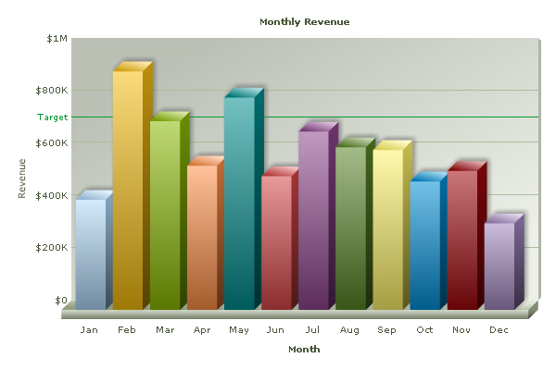

Creating your first chart
To become aquanted with Fusion Charts, you will want to create your own data xml and generate the Fusion Chart from your html page. A simple step by step process can be followed on the FusionCharts Documentation found at (http://www.fusioncharts.com/docs/). After creating your first chart, you should try experimenting with the different chart properties and chart types using the Chart XML API (also on the FusionCharts documentation) as your guide.

Fusion Charts and Java

Location of Required Fusion Chart files
There is a mix of Java classes, jsps, javascripts, and chart swf files in order to work with Fusion Charts.
List of Java classes you will need to build Fusion Charts
Package FusionCharts
ChartFactory.java – builds the data string xml and the embeddable DOM tag
ChartType.java – enum that holds values for the type of charts available
Graph.java – Generic Graph class that provides generic members and methods
FusionGraph.java – Extends the Graph class and provides FusionChart specific members and methods
Series.java – Series class that holds each series and all their values
Resources
XMLWriter.jar – helper xml api that helps ChartFactory build the data xml string.
List of jsps needed to build Fusion Charts
chartBuilder.jsp – A helper jsp that I created so that users do not have to put in the redundant code needed by FusionChartsRenderer.jsp and FusionChartsHTMLRenderer.jsp

List of Javascripts needed to build Fusion Charts
/FusionCharts
FusionCharts.js – required Fusion Charts javascript file that displays your chart
FusionChartsDOM_commented.js – required javascript to use DOM tags
Flash files needed to build Fusion Charts
Steps to build a Fusion Chart in Java
Please ensure that you have example.jsp and example_alternative.jsp open in order to follow the steps below to build a fusion graph.

Create FusionGraph
First you will want to create a FusionGraph object and set its properties
To create a FusionGraph object you will need to define a Graph Id, Chart Type which is an enum from ChartType and the size of items in each of it’s series. Let’s start with a simple pie graph example that has 5 slices.
FusionGraph pieGraph = new FusionGraph(“pieGraph”,ChartType.PIE3D,5,request);
Note that the request parameter is required so that we can send the FusionGraph object within jsps.
Next you may want to set the properties of the graph by giving it a customized look. Please refer to the Chart XML API found in http://www.fusioncharts.com/docs for the properties you can customize.
For example if I wanted to set the background of the graph to a gradient of white and yellow I would do this:
graph.setChartProperties(“bgColor”,”FFFFFF,CCCC33”);
You will also want to set the width and height of the graph by using the setWidth(int) and setHeight(int) methods, or just go with the default which is width=600, height=300.
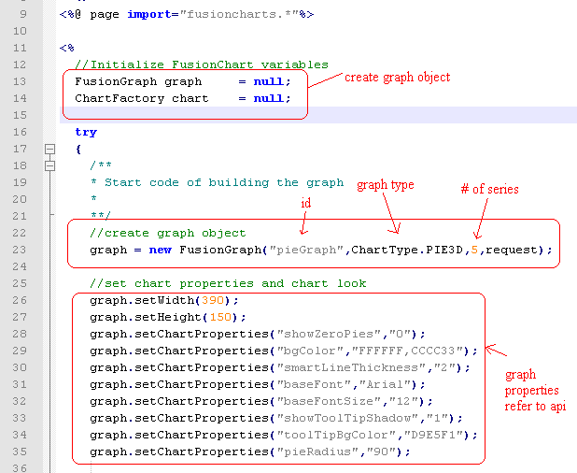
Now to create a series inside the graph:
Series series = graph.createSeries(“pieSeries”);
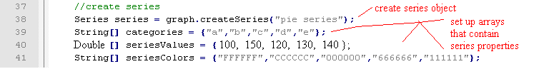

Series
You will have one or more series containing data.
The series object has a set of member properties that you can set. Please refer to the API for more information.
For the pie graph you will probably want to set the values, and the colors for each pie.
To do this you can use the setColor(int index, String color) and setValue(int index, double value) methods.

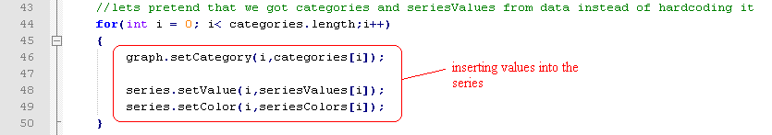

ChartFactory
When you are finished creating the graph, you will want to put the graph in a ChartFactory so that the Chart Factory can build the desired xml string for the data. To generate the data for the pie graph, code the following:
ChartFactory chartFactory = new ChartFactory();
chartFactory.insertGraph(pieGraph);
chartFactory.buildFusionChart(“pieGraph”); //or use pieGraph.getGraphId() for the String parameter
New: A new method called “buildDOMFusionChart(String graphName) was created so that we could utilize the FusionChartsDOM_commented.js which allows us to use an html tag to display the fusion chart.
All you need to do is add the following line instead of “chartFactory.buildFusionChart(“pieGraph”)
You would use on the jsp
chartFactory.buildDOMFusionChart(“pieGraph”);
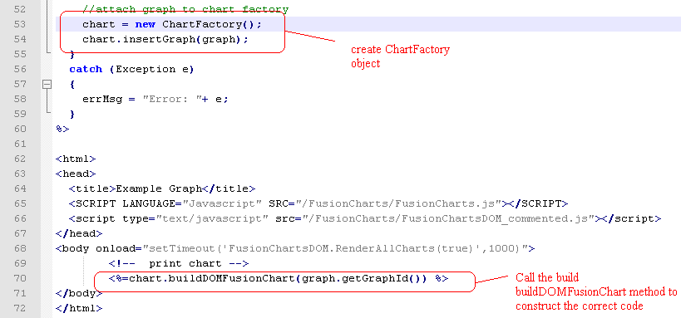
You will need to include in your body tag
<body onload="setTimeout('FusionChartsDOM.RenderAllCharts(true)',1000)">
In addition make sure you have the scripts loaded into your jsp if you are using jsp
<SCRIPT LANGUAGE="Javascript" SRC="/FusionCharts/FusionCharts.js"></SCRIPT>
<script type="text/javascript" src="/FusionCharts/FusionChartsDOM_commented.js"></script>
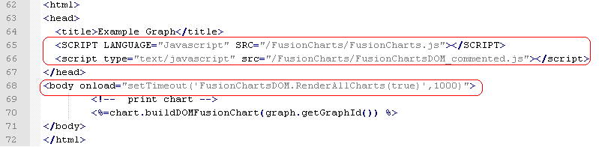

Using the helper chartBuilder.jsp
The chartBuilder.jsp has built in Javascript that works with FusionCharts.js and renders the chart for you provided that you provide the correct graph parameter. You can either use this method or the buildDOMFusionChart method which is newer.
All you need to do is provide the graphId of the graph you want to display
For example if I wanted to display the pie graph from the earlier examples, I would do this
<jsp:include page=”/tools/chartBuilder.jsp” flush=”true”>
<jsp:param name=”graphId” value=”pieGraph”/>
//or use <%=pieGraph.getGraphId() %> instead of the string
</jsp:include>
Note: You must use example_alternative.jsp to see this
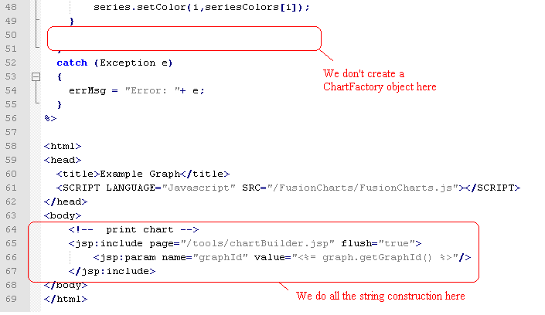

Example.jsp and example_alternative.jsp
Please take a look at the example.jsp attached that will help you build a pie graph using the DOM method. Example_alternative.jsp provides an example of building a chart using the chartBuilder.jsp method. The drawback of using the chartBuilder.jsp method is that you make another server call when calling that jsp. So with pages that have many charts, it will be better using the DOM method.

